Chapter 5 programming practice

# Paging algorithm

Given the common.h

## Common.h

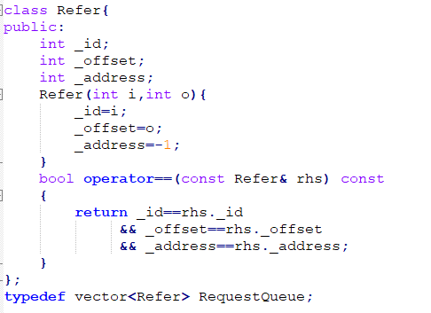

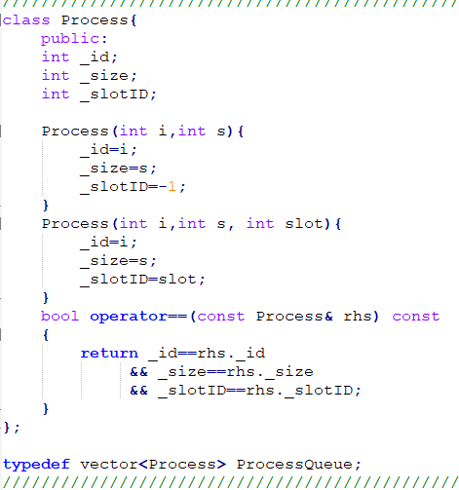

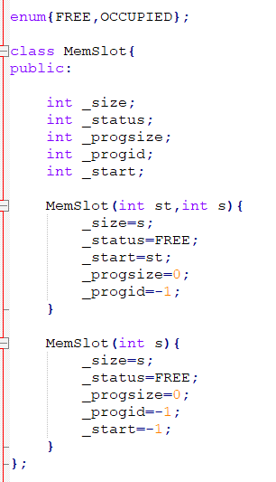

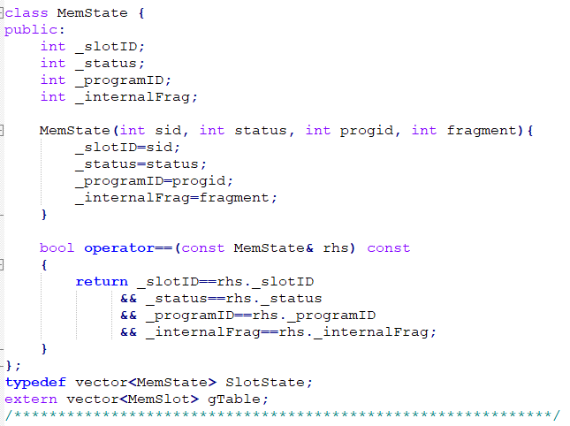

Implement three procedures

## main.cpp

This contains the variable declaration and test case.

## Makefile

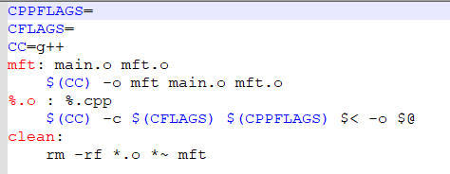

# Problem

Write the three procedures in the mft.cpp file

PUT YOUR NAME AND STUDENT ID in the mft.cpp file

/*NGUYEN VAN TUNG 10029302*/